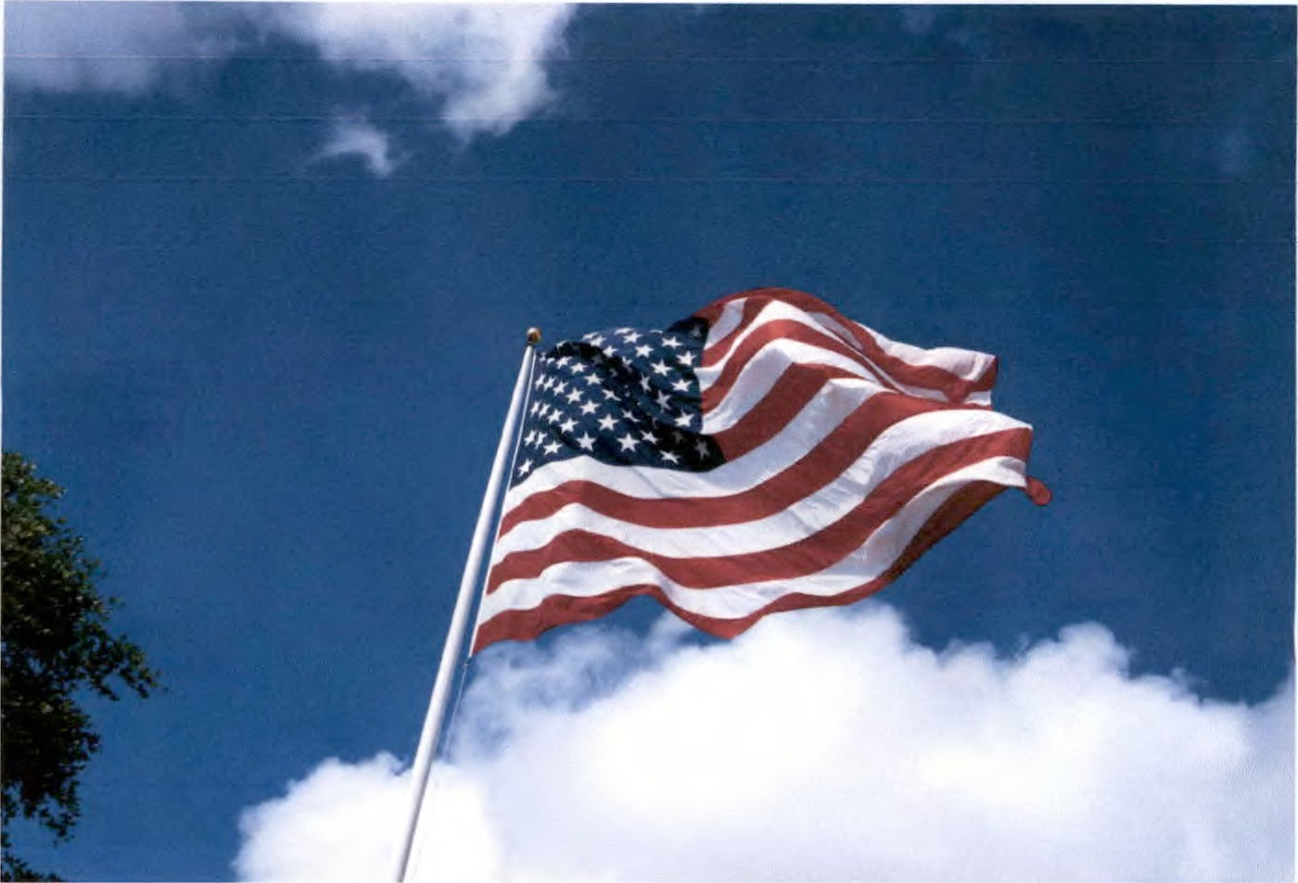
TO PUBLIC: Canvass of the May 26th, Primary Runoff will be held on June 4th, 2026 at 10:00 a.m. in the County Commissioner Court Room.
Taylor Elliott
Early Voting Clerk, Election Administrator
County and District Clerk

